Corrigendum for Cunningham, Gleditsch, Salehyan. 2009.”It Takes Two: A Dyadic Analysis of Civil War Duration and Outcome”, Journal of Conflict Resolution 53(4): 570-597.

Kristian Skrede Gleditsch
Department of Government
University of Essex
ksg@essex.ac.uk
13 January 2010

We have been alerted to an error in the way that the data for the original published article was set up for survival analysis in Stata, leading to an incorrect specification of the hazard function in the reported Cox analysis.

We sincerely apologize for this error – for which Kristian Skrede Gleditsch is solely responsible – and we are grateful to Michael Tiernay for alerting us to this.

We have revised the replication archive to include a new file with the data revised with the correct setup. In this memo we report the results with the revised data with the corrected setup and provide a brief summary of the implications for the discussion in the published article.

To recap, in the original article we presented three hypotheses on conflict termination tested by the hazard rates for different covariates (p. 577), namely:

Hypothesis 1: Conflicts between governments and strong rebels will be shorter.

Hypothesis 2: Conflicts between governments and rebels that control territory in the
periphery will be longer.

Hypothesis 3: Conflicts will be shorter when the rebels have greater opportunities to substitute

Table 3 displays the revised results for using the disaggregated measures of rebel strength, while Table 4 displays the revised results using the aggregate measure of the strength of rebels relative to the government. Although the signs of the coefficients in general do not change with the revised data with the corrected setup, the changes in the coefficients and estimated standard errors imply some differences with regards to significance tests.
Table 3: Results based on the corrected data
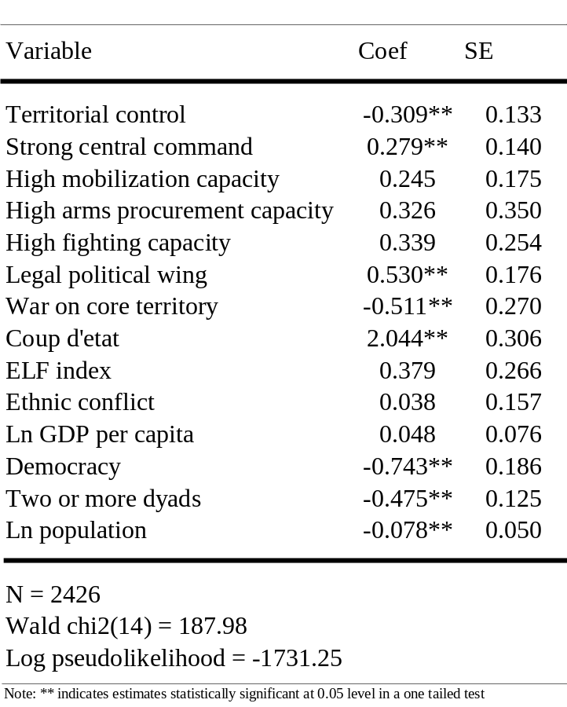

In our originally published article, we argued that “all of the indicators of strong nonstate actors in model 1 increase the hazard rate, or make it more likely that a conflict will end when rebels can pose a serious challenge to a government”, and although not all of the coefficients are “significant at conventional levels, we see these results as providing considerable evidence in support of hypothesis 1, that insurgents with stronger military capabilities tend to be associated with shorter conflicts.” This statement can still stand, although mobilization capacity and fighting capacity are no longer statistically significant while strong central command now is.

The conclusions regarding hypotheses 2 and 3 remain unchanged, i.e., conflicts are less likely to end when rebels have territorial control, and they are more likely to end when rebels have a legal political wing.

Table 4: Results based on the corrected data
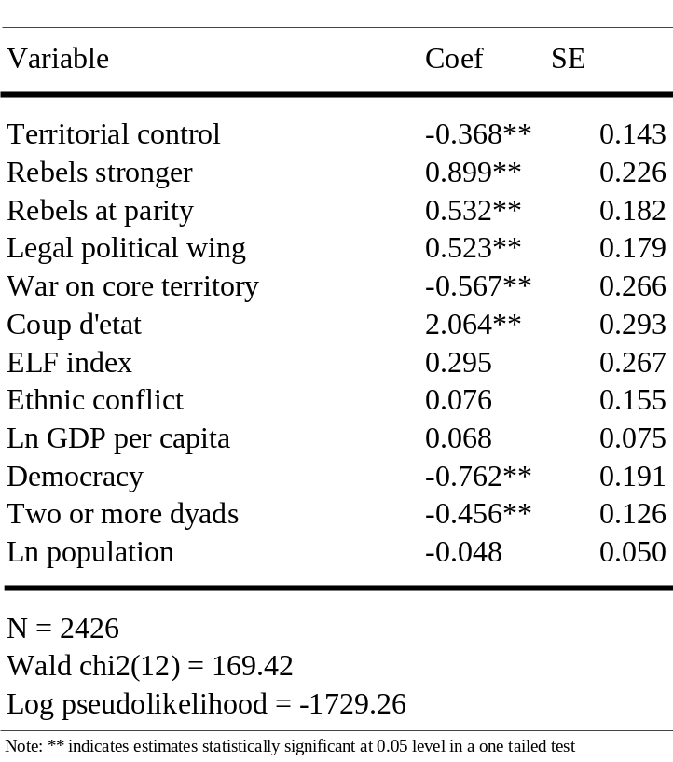

Some of the conclusions regarding the control variables change when the data are corrected, and we have tried to identify all incorrect statements in the originally published article below.

Although the coefficient estimates for strong central control and high fighting capacity are not significant at conventional levels, we see these results as providing considerable evidence in support of hypothesis 1, that insurgents with stronger military capabilities tend to be associated with shorter conflicts (p. 586).

This statement is no longer correct, since strong central command is now significant.

Civil wars appear to last longer in countries with higher populations and with lower incomes (p. 587).

Although the sign of these coefficients remain the same with the corrected data, neither of these coefficients are now statistically significant.

